Predicting The Energy Output Of Wind Turbine based on Weather Conditions

Project Report

**INDEX**

|  |  |  |  |  |  |  |  |  |  |  |  |  |  |  |  |  |  |  |  |  |  |  |  |  |  |  |  |  |  |  |  |  |  |  |  |  |  |  |  |  |  |  |  |  |  |  |  |  |  |  |  |  |  |  |  |  |  |  |  |  |  |  |  |  |  |  |  |  |  |  |  |  |  |  |  |  |  |  |  |  |  |  |  |  |  |  |  |  |  |  |  |  |  |  |  |  |  |  |  |  |  |  |  |  |  |  |  |  |  |  |  |  |  |  |  |  |  |  |  |  |  |  |  |  |  |  |  |  |  |  |  |  |  |  |  |  |  |  |  |  |  |  |  |  |  |  |  |  |  |  |  |  |  |  |  |  |  |  |  |  |  |  |  |  |
| --- | --- | --- | --- | --- | --- | --- | --- | --- | --- | --- | --- | --- | --- | --- | --- | --- | --- | --- | --- | --- | --- | --- | --- | --- | --- | --- | --- | --- | --- | --- | --- | --- | --- | --- | --- | --- | --- | --- | --- | --- | --- | --- | --- | --- | --- | --- | --- | --- | --- | --- | --- | --- | --- | --- | --- | --- | --- | --- | --- | --- | --- | --- | --- | --- | --- | --- | --- | --- | --- | --- | --- | --- | --- | --- | --- | --- | --- | --- | --- | --- | --- | --- | --- | --- | --- | --- | --- | --- | --- | --- | --- | --- | --- | --- | --- | --- | --- | --- | --- | --- | --- | --- | --- | --- | --- | --- | --- | --- | --- | --- | --- | --- | --- | --- | --- | --- | --- | --- | --- | --- | --- | --- | --- | --- | --- | --- | --- | --- | --- | --- | --- | --- | --- | --- | --- | --- | --- | --- | --- | --- | --- | --- | --- | --- | --- | --- | --- | --- | --- | --- | --- | --- | --- | --- | --- | --- | --- | --- | --- | --- | --- | --- | --- | --- |
| |  |  |  |  |  |  |  |  | | --- | --- | --- | --- | --- | --- | --- | --- | | **1** | |  | **INTRODUCTION** | |  |  |  | |  | |  | 1.1 Overview | |  |  |  | |  | |  | 1.2 Purpose | |  |  |  | | **2** | |  | **LITERATURE SURVEY** | |  |  |  | |  | |  | 2.1 Existing problem | | |  |  | |  | |  | 2.2 Proposed solution | | |  |  | | **3** | |  | **THEORITICAL ANALYSIS** | |  |  |  | |  | |  | Block diagram | |  |  |  | |  | |  |  | | |  |  | | **4** | |  | **EXPERIMENTAL INVESTIGATIONS** | | |  |  | | **5** | |  | **FLOWCHART** | |  |  |  | | **6** | |  | **RESULT** |  |  |  |  | | **7** | |  | **ADVANTAGES & DISADVANTAGES** | | |  |  | | **8** | |  | **APPLICATIONS** | |  |  |  | | **9** | |  | **CONCLUSION** | |  |  |  | | **10** | |  | **FUTURE SCOPE** | | **`** |  |  | | **11** | |  | **BIBILOGRAPHY** | |  |  |  | |  | |  | **APPENDIX** | |  |  |  | |  |  | | A. Source code | |  |  |  | |  |  | |  |  |  |  |  | | | |  |  |
|  | | |  |  |
|  | | |  |  |
|  | | |  |  |
|  |  |

**INTRODUCTION**

**1.1 Overview**

Wind energy is playing a critical role in the establishment of an environmentally sustainable low carbon economy. Traditionally, DC machines, synchronous machines and squirrel-cage induction machines have been used for small scale power generation. For medium and large wind turbines (WTs), the doubly-fed induction generator (DFIG) is currently the dominant technology while permanent-magnet (PM), switched reluctance (SR) and high temperature superconducting (HTS) generators are all extensively researched and developed over the years.

Currently, wind power is widely recognized as a main feasible source of renewables which can be utilized economically in large quantity.in United Kingdom the usable offshore wind energy alone is enough to provide three times more than the required electricity consumption in the country, given sufficient support. However, wind power fluctuates by its nature and such applications demand high reliability and high availability while the market is still looking to reduce weight, complexity and operational costs.

**1.2 Purpose**

This code pattern shows you how to tap into massive data sets to mine insight. You’ll build a news mining web application with the Watson Discovery Service using the Watson Node Red SDK. The app demonstrates two use cases using Watson Discovery News:

* **Search:** Query for the most relevant new articles about a specific topic or subject. Because the news collection is pre-enriched with natural language processing, we can query not just on keywords or categories but also on concepts, sentiment, and relations to get richer search responses.
* **Trending topics in the news:** Identify popular topics over the past 24 hours. Topics can be general or specific to an industry or category.

**LITERATURE SURVEY**

**2.1 Existing problem**

The Energy prediction applications are more complex to create and are not analyzed properly because of which the customer is not satisfied with the applications.

The New Energy predicting application is needed to be updated with the new algorithms with easy development .The new energy predicting application should be more trained and trained data set should be correct and should not overfitted.

**2.2 Proposed solution**

By using IBM Cloud, Node Red and Watson Discovery it makes the application development much easy and reduces the complexity of the application. This application is easy to develop and it also having chat box for user quires .User can simply enter the parameters which are considered for performance measures and he/she will get the performance condition for that wind turbain.

**THEORITICAL ANALYSIS**

**Block diagram**

Get Result

Enter energy grnerated(MW)

Enter numberof rotations(Rpm)

Enter wind speed(Km/hr)

**EXPERIMENTAL INVESTIGATIONS**

In this process of developing the project I have undergone many investigation processes to learn and understand new concepts so that I can build the news search application successfully. For I had to learn and investigate following:

* IBM Cloud.
* Node Red.
* Watson Discovery.
* Slack bot.
* Integrating the Slack bot with Watson discovery.

**FLOWCHART**

**RESULT**

**UI Interface:**

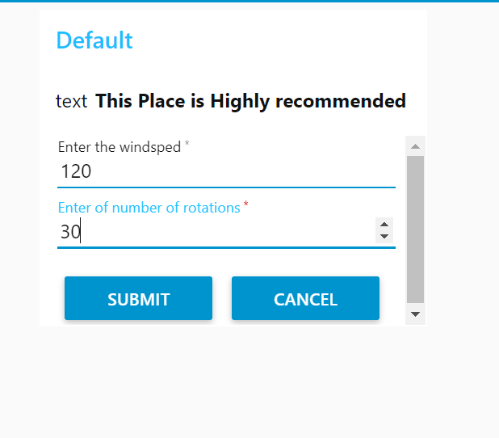

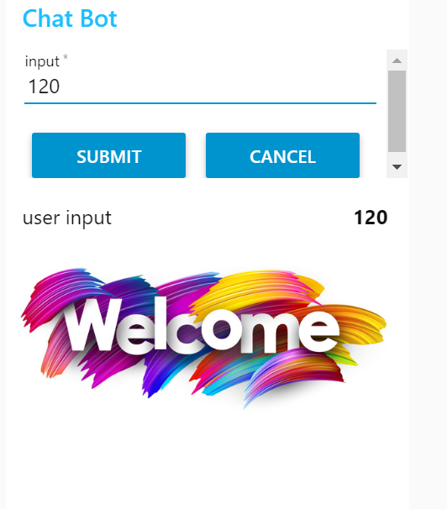

**Chat Bot:**

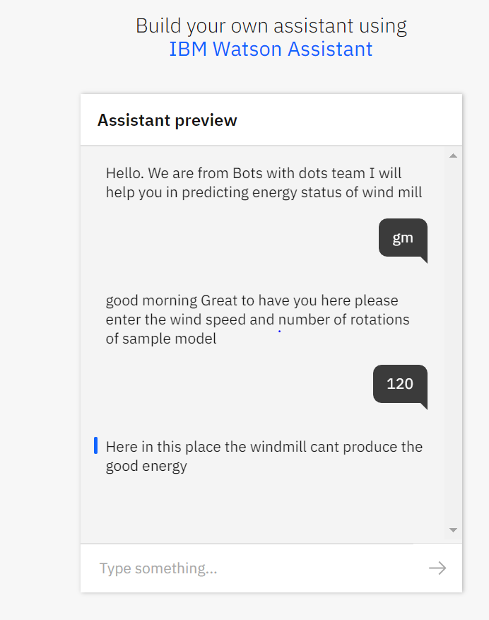

**Watson Output:**



**ADVANTAGES**

This ANN based model will informs us the condition of the wind turbain. And this model is

* Easy to create.
* Less time required to develop.
* High performance with IBM cloud.

**DISADVANTAGES:**

The Watson news search application includes following disadvantages:

* We need to pay for IBM platform service.
* The services which we use require amount for space we use.

**APPLICATIONS**

The application is developed using ANN so this will work not only for ‘predicting the energy output of the wind turbain’ but also works for water motor health prediction here water motor means motors with high capacity which are generally used in the factories by using this model we can estimate the performance of them in order to running production with out any deviation in large scale and small scale factories. The difference between both these is only the data set according to the parameters for measuring the performance taken by us.

**CONCLUSION**

This project gave us some knowledge about ‘Artificial Neural NETWORK’ and working of the Wind tubains which are used for power generation .This project also tells about the integration process of slack with the Watson services to access and create your own bot to query news from the channel.

**FUTURE SCOPE**

The Project is developed using ANN so this will work not only for ‘predicting the energy output of the wind turbain’ but also works for any project which is based on energy prediction. The difference is only the data set according to the parameters for measuring the performance taken by us.

**Names**: G Sumanth Naga Deepak

Nikhil Kandibanda

Akhil Chitirala

Alla Keerthi Reddy

**College Name**: Koneru Lakshmaiah Education Foundation,Guntur.

**Work Title:** Predicting the Energy output of Wind Turbine based on Weather Conditions

**References:**

1. IBM Cloud: <https://www.ibm.com/cloud/get-started>
2. Node red tutorial: <https://developer.ibm.com/tutorials/how-to-create-a-node-red-starter-application/>
3. About API:

<https://www.youtube.com/watch?v=s7wmiS2mSXY&feature=youtu.be>

1. Watson services and product: <https://www.ibm.com/watson/products-services>
2. IBM Watson Discovery: <https://developer.ibm.com/articles/introduction-watson-discovery/>

**APPENDIX**

**Link to Node Red work space:**

<https://node-red-cfqck.eu-gb.mybluemix.net/red/#flow/bdc9b1c8.026aa>

**Link to Node Red UI:**

<https://node-red-cfqck.eu-gb.mybluemix.net/ui/#!/2?socketid=G9j_FWOHm5M6Iy0zAAAf>

**Preview Link for chatbot:**

<https://web-chat.global.assistant.watson.cloud.ibm.com/preview.html?region=eu-gb&integrationID=a3b9a717-cbfb-4493-97d3-606da9bc86c9&serviceInstanceID=254c8060-980d-4ee6-9dfe-c9b9d2d33efb>